1. 
2. 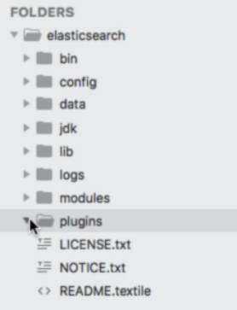
3. **Agenda**: Let’s explore the elasticsearch directory.
4. Let’s go inside **bin directory**.
   1. **Binary Scripts**: Such as elasticsearch.bat to run an instance of elasticsearch.
   2. Other helper utilities such as
      1. **elasticsearch-plugins**: To install plugins
      2. **Elasticsearch-sql-cli**: To run elasticsearch SQL queries.
5. Let’s go inside the **config directory**: Containing a number of configuration files where we can configure elasticsearch.
   1. **elasticsearch.yml**: That is main configuration file for elasticsearch.
   2. Let’s mention a couple of settings in this file.
   3. All of the settings in this file are commented out, meaning that default values are being used.  
      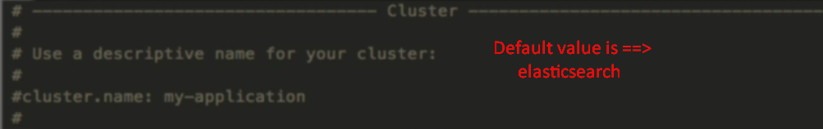
   4. 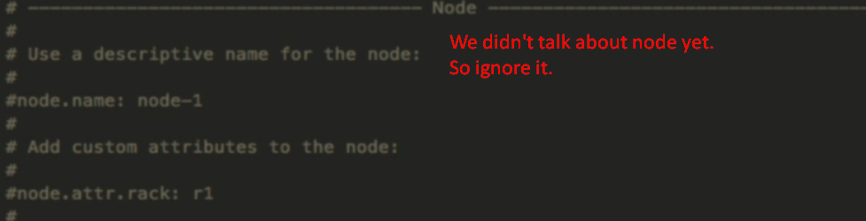
   5. 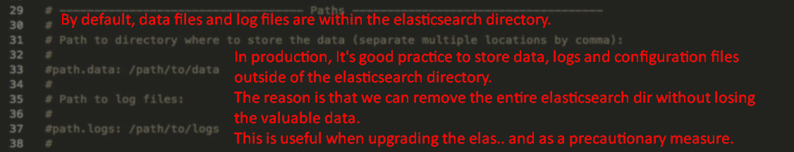
   6. Specifically, we can configure Elasticsearch to bind to a different IP address, as well as specify a custom port.
   7. 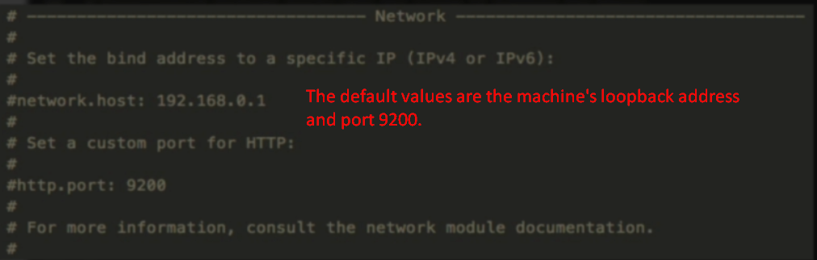
   8. The “Discovery” section is related to how multiple instances of Elasticsearch are connected, which is not relevant to us right now. 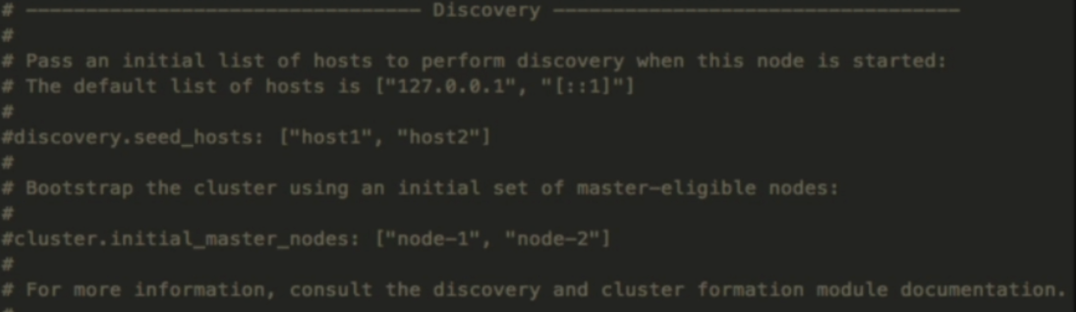
   9. This file doesn’t contain all of the available settings, but rather the most important ones.
6. Then we have a file jvm.options.
   1. Since Elasticsearch is built with Java, it runs within a JVM, which has a certain amount of reserved memory.  
      More specifically, the JVM’s Head Size.
   2. You can configure how much memory should be made available to Elasticsearch at the top of the file if you need to.  
      Default value is 1GB.
   3. Rest of the settings is very advanced. Please don’t change if you don’t kow.
7. log42.properties file:
   1. Elasticsearch uses the log4j2 logging framework for writing various information to log.
8. The rest of the files in config dir is related to configuring the users and their roles.  
   We will not cover them here as such settings are configured in Kibana instead of within configuration files.
9. The JDK dir contains the JDK that Elasticsearch ships with.
10. The lib dir contains a no of dependencies that Elasticsearch needs including Log4j logging framework and Apache Lucene, which Elasticsearch is built on top of.
11. The modules directory contains a number of built-in modules that provide some additional functionality to Elasticsearch.

These are enabled by default, so the purpose of them is just to have the code for a number of features self-contained.   
As you can see, towards the end of the list, this is where the X-Pack features are located. You will see a number of these modules in action throughout the course, although it is completely transparent to us that the functionality comes from a module.

1. The plugins dir which is now empty as we didn’t add any plugins yet.
2. So, what is the difference b/w a plugin and a module?
3. Modules ship with Elasticsearch whereas plugins are a way for us to add custom functionality to Elasticsearch.  
   That could be 3rd party plugins, or ones developed by ourselves.  
   Another difference is that these plugins can be removed but not any module.
4. In case, you ever come across a variable named “$ES_HOME”, then that is an environment variable that points to the root of the Elasticsearch directory.